Laboratory Practical Report

of

**GRAPH THEORY**

**(ICT ED 478)**

Submitted To

**TRIBHUVAN UNIVERSITY**

In Partial Fulfillment of the Requirements of the course

**B.Ed. ICTE 6th Semester**

Submitted By

Sanam Tamang

Symbol No.: 76214020

T.U. Regd. No.: 9-2-214-54-2019

Under the guidance of

**MR. KALYAN DAHAL**

Lecturer

Sukuna Multiple Campus

**Directed path and cycle**

Directed path:

A directed path is defined as an open directed walk with all distinct vertices and hence the edges.

An open directed walk W is called a directed path if all the vertices (and hence arcs) in W are distinct.

Directed cycle:

It is a directed path in all vertices are different except first and last vertices. Actually, it is a closed directed path.

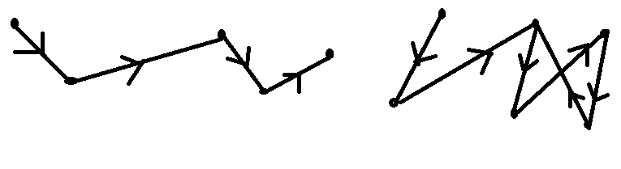

W: $v_{0}$, $e_{1}$, $v_{1}$, $e_{2}$, $v_{2}$, $e_{3}$, $v_{3}$, $e_{4}$, $v_{4}$ [left side figure] – directed path

W: $v_{2}$, $e_{3}$, $v_{3}$, $e_{4}$, $v_{4}$, $e_{5}$, $v_{5}$, $e_{6}$, $v_{6}=$ $v_{2}$ [ right side figure]- directed cycle